*Coconut Poached Salmon*

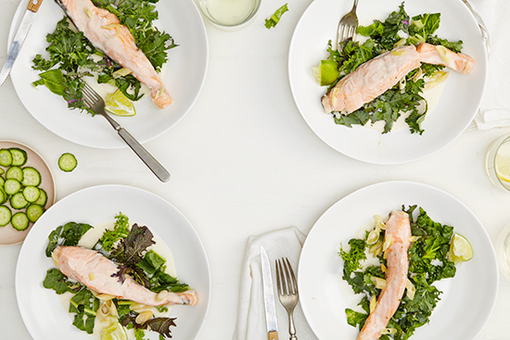

Coconut milk poaching is indulgent and super warming for this time of year. We found our way around fish sauce (which we love but is not detox friendly) by sneaking in a few anchovies at the end.

*ingredients*

makes 2

* 2 quarter pound pieces of salmon, seasoned with salt + pepper
* 1-2 anchovy filets
* 1/2 cup vegetable, chicken or seafood broth
* 1 cup coconut milk
* 2 stalks lemongrass (inner bulbs), finely chopped
* 1 lime, juiced
* dark, leafy winter greens, finely chopped
* salt + pepper to taste

*preparation*

|  |  |
| --- | --- |
| 1. | Add the broth to a large, deep pan over medium high heat. Cook for a few minutes until it begins to boil and add the lemongrass, cooking it for a minute until fragrant. Reduce heat to medium and add the coconut milk and most of the lime juice and place the salmon fillets into the liquid skin side down. Cover and poach for about 10 minutes until cooked through. Transfer fillets to a serving platter over dark, leafy winter greens. |

|  |  |
| --- | --- |
| 2. | Continue to cook the liquid for another minute or so until thick, adding in the anchovies and smashing them into the sauce with the back of a wooden spoon. Season the sauce with salt and pepper to taste and spoon over salmon and greens. Squeeze remaining lime over the salmon and serve. |